# Welcome Back Tigers!

## Contact Information

Email: [cratcliff@oakparkusd.org](mailto:cratcliff@oakparkusd.org)

Phone: (805)

## PE Class Notes

Parents, throughout the school year you may get a few notes from me informing you about student progress, upcoming activities, units, projects, etc. I want you to feel included and be informed of what is going on with your Tiger in PE.

## PE Class Helper

I am more than happy to have parent volunteers come in and help during their child’s class. Feel free to contact me if you are available and willing to help. I will get you signed up for a day and time!

## What’s Class Dojo?

## Class Dojo is an app that lets parents and students track their behavior in PE and can be downloaded to android and iPhone devices.

Hello, Tigers and Tiger Parents! Welcome back! I am the new PE teacher here at Brookside Elementary. My name is Ms. Ratcliff (soon to be Mrs. Deckrow on Nov. 22). I am so excited to get to know you all over the 2014-2015 school year. You Tigers are going to have a great time in PE class and are going to learn all kinds of new skills! This is my first year here at Brookside Elementary so should you stumble upon me, feel free to come say hello and introduce yourself.

Let’s Get moving!

Aliquam sed eros | Nulla facilisi | Lorem vitae elit

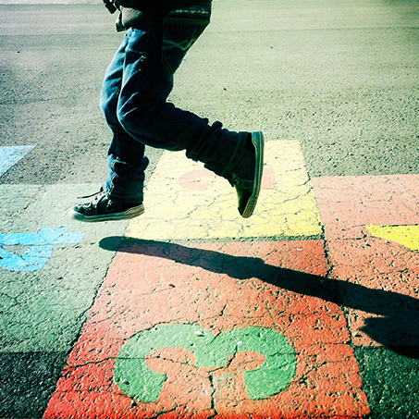

What can I expect in PE?

We will be focusing on a number of things in PE, but to give you an idea, the main focus in class will be participating in daily physical activity, contributing positively to the PE classroom, and learning to take responsibility for one’s actions. These three things make the PE classroom a very productive and FUN place to be.

*What should I do to prepare for PE?*

Please make sure that on PE days you come to school in clothes that will allow you to participate fully in PE (flexible clothes that will not restrict movement and athletic shoes). Be sure to pay attention to what the weather is like outside. Most of the time we will be outdoors (unless it is raining), so if the weather is cold make sure you have a sweatshirt or jacket to wear outdoors to PE. Similarly, if the weather is hot make sure that you are not dressed in clothes that will cause you to overheat. I will always allow students to get water during class at appropriate times, but water bottles are also a very good idea for PE.

Sometimes I might ask if you have any extra PE supplies at home that you might share with your class, feel free to bring that if asked, just m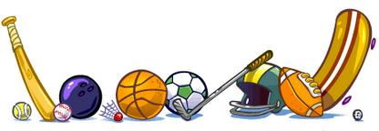ake sure you bring it back to class after you finish up with PE.

**Class Dojo Cont.**

Students receive positive Dojo points for: following directions (listening, participating, staying on task, following rules), contributing positively (helping others, being kind, working hard, helping clean up, helping set up, encouraging others, being a good sport, having a good attitude), taking responsibility (working out an issue with someone else, apologizing, being fair, accepting a consequence without grumbling, being a leader, respecting other people’s feelings, taking good care of school equipment).

Students receive negative Dojo points for:

Not following directions (talking out of turn, being off task, disobeying, defiance, distracting others), being negative (being rude to others, having a bad attitude, talking back, interrupting, being a poor sport), not taking responsibility (tattling, refusing a consequence, cheating, not contributing to their team or group, not taking care of school equipment).

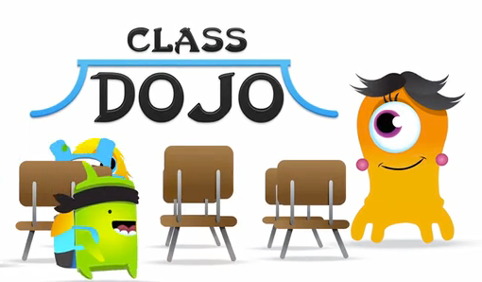

How should I behave in PE?

PE is a class just like when you are inside with your teacher. It is important that you are listening to instruction and following directions like you do inside your classroom. Just because we are outside does not mean that it is recess!

I have very high behavior standards. Following or not following the rules is a choice that is made, but each choice has a consequence, be ready to face that consequence either way! These consequences are given to you in the form of class Dojo points.

Class Rules to follow to ensure PE is FUN:

1. Listen to instructions and follow them.
2. Be positive and respectful to yourself and others.
3. Your body parts are just for you.
4. Use PE equipment the right way.
5. Be responsible for your own actions.